
Design and Construction of Ackerman Steered Robot

Deliverable 4
EML4551

Group 14
October 16, 2008

QUINN, KYLE
SOSA, JULIO
STEEL, ROBERT
WOODS, TREVOR


Table of Contents

Abstract 2

Introduction 2

System Design Breakdown 3

Concept Generation 4

Concept Selection 10

Conclusion 11

Resources 12
Abstract

Our group in the senior design course at the FAMU-FSU College of Engineering is tasked with designing and constructing an Ackerman steered robotic vehicle for the Center for Intelligent Systems, Control, and Robotics. Design specifications previously decided upon were used to break down the development of the product into categories, and generate concepts for the vehicle. These concepts were then scored based on their strengths, and the requirements of the product. A double wishbone suspension system combined with the required Ackerman steering specification was found to be the best choice for our final product.

Introduction

Our group’s Senior Design project here at the FAMU-FSU College of Engineering is to design and construct an Ackerman steered robot. The customer and funding source is the Center for Intelligent Systems, Control, and Robotics (CISCOR) here at the college. This product will serve as the platform for testing intelligent controls systems on and off road. Previous deliverables can be found via our group website, and can provide greater detail into the project scope.
Currently, the project is in the concept generation and selection stages. This document will serve as the control for this important step in the design process. Before problem break down and concept generation, however, it is important to consider design specifications previously decided upon.
- 4-Wheel Ackerman Steering
- 4-Wheel Drive
- Independent Suspension
- Dry Weight (Unloaded) – 150lb
- Wheelbase 36x36”
- Ground Clearance – 4”
- Body Height 16”
- Capable of Traveling through 5”-6” of standing water
- Top Speed _ 10mph or greater
- Towing Capacity – 100lb
- Climb 30º incline
- Function for 60 minutes between charges
- Easy Assembly
- Ability to rotate on its own radius
The concepts developed were built based on the goal of achieving all of these specifications when the final product is reached. The problem was broken down into subsystems for more efficient generation of ideas, and problem solving. Each subsystem was approached individually, and when combined will give the different design cases from which we had to choose from. What follows is the thought process behind problem breakdown, solution, and concept decision.

System Design Breakdown

General
The robot as a whole will need to integrate as many components in order to achieve full autonomy. Because of this, our design must not only serve the vehicle components concerning drive train and suspension, but must also encompass all electronic systems, motors, controllers, and other equipment necessary for operation. Many of these items, as stated before, have been provided by CISCOR, and can be found in Deliverable 3. The general layout of the final product will need to provide adequate space for each component, and be easily disassembled for maintenance and future upgrades. Additionally, the product will have to meet preliminary design specifications as closely as possible.

Ackerman Steering
Our primary goal, as well as the only non-negotiable vehicle system, Ackerman steering provides the base for all of our concept generations. Per request of the customer, we will be implementing a 4-wheel steering system, with an individually controlled motor for each wheel. The result should be a design that can be mirrored from the front to rear of the vehicle. Since this vehicle is intended for off road use, special attention must be given to the ground clearance of steering linkage. In addition, the joints that make up the mechanism must work in such a fashion that they will not shear or otherwise fail due to the stress of all terrain travel. However these are detailed design considerations, and for the purposes of concept generation, we need only consider the mechanism design. A working 4-wheel steering model will be the best way to conceptually integrate this specification into the robot. This leaves, however, no room for choice. Ackerman steering is, and will continue to be the only option for steering design by customer request.

Frame
Frame design is important for a number of reasons. First off, it provides a structure from which all components have a connection to, either direct or in-direct. Also, when combined with suspension design, is the basis for vehicle rigidity and ride. The frame must be constructed in such a fashion that it works in conjunction with suspension. More importantly for our product, care must be taken to make sure the frame does not interfere with the 4-wheel Ackerman steering design.

Suspension
From a suspension standpoint, ride comfort is not an issue since the product is an autonomous robot. Ride, however, is still important due to the fact that a rigid vehicle would transfer vibrations and all other loads directly to any attached component. In addition, a good suspension design will aid the vehicle with more efficient travel through the rough terrain planned for. As stated before, the suspension and the frame work hand in hand; so much so in fact, that each concept generation will have a suspension design paired to a particular frame, so as to verify that components are of best fit. Due to our 4-wheel drive and steering requirement, and our lack of standard drive axles, the suspension cases must all be based on independent suspension designs in both the front and rear. In generating suspension and frame combinations, we must also take into account how we will be able to meet product specifications during final design.

Concept Generation

General
Our general concept for the design of the robot incorporates the use of 1” square steel tubing with a wall thickness of 0.125”. This will allow ample strength to support our design requirements. The decision to use square tubing in lieu of round tubing was primarily for ease of fabrication. Because the bar is square, it will be easier to cut and fit together than round bar. Also, because of the flat surfaces that the sides provide, it will be easier for us to attach the suspension and steering components.
Our frame design is influenced by the robots that CISCOR currently owns and tests. They are small and mostly rectangular shaped. Our frame design will also be dictated by other system components, mainly the batteries, motors, and computing equipment (Figure 1). Considering cost, fabrication, and other factors, it was decided that a basic cube shape would be the easiest and most efficient design to accomplish all the things that the customer wants.

Figure (1) General Layout
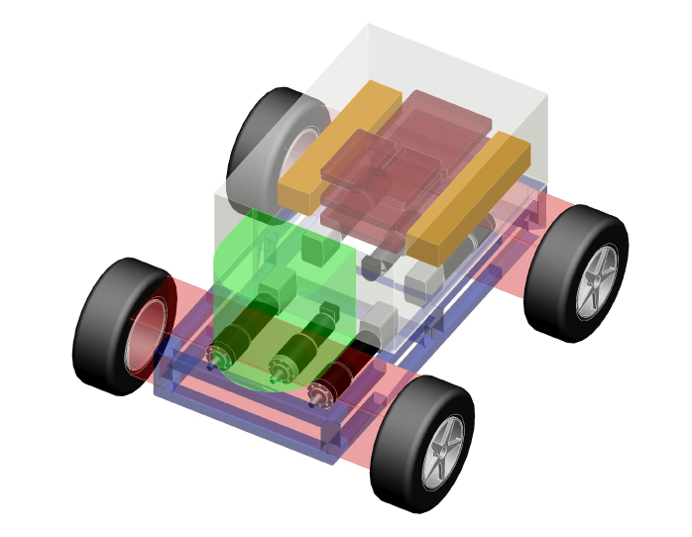
Currently we have laid out our motors with all of the drive motors running parallel to the left and right side (Figure 2). This configuration allows us a simple design and one that is easily worked on, should a motor need to be serviced or replaced.

Figure (2) Motor Configuration/Bottom View
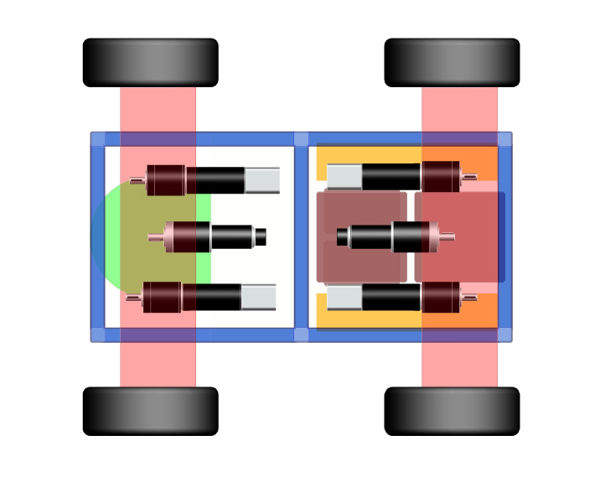

Ackerman Steering
Ackerman steering utilizes a spindle at each of the front wheels that pivot about a king pin. Each spindle is connected to each other through the use of tie rods and a rack and pinion. The linkages connecting the spindles form a trapezoid (Figure 3) and thus allow each spindle to follow a different radius, depending on if it is the inside or outside wheel. The difference in the radius account for the inside wheel traveling farther than the outside. The draw back of this system is that it is only accurate in three positions throughout its range of motion (straight ahead and one position in either direction). It is, however, for the scope of this project, the required, as well as best choice for our steering design.

Figure (3) Ackerman Steering Design
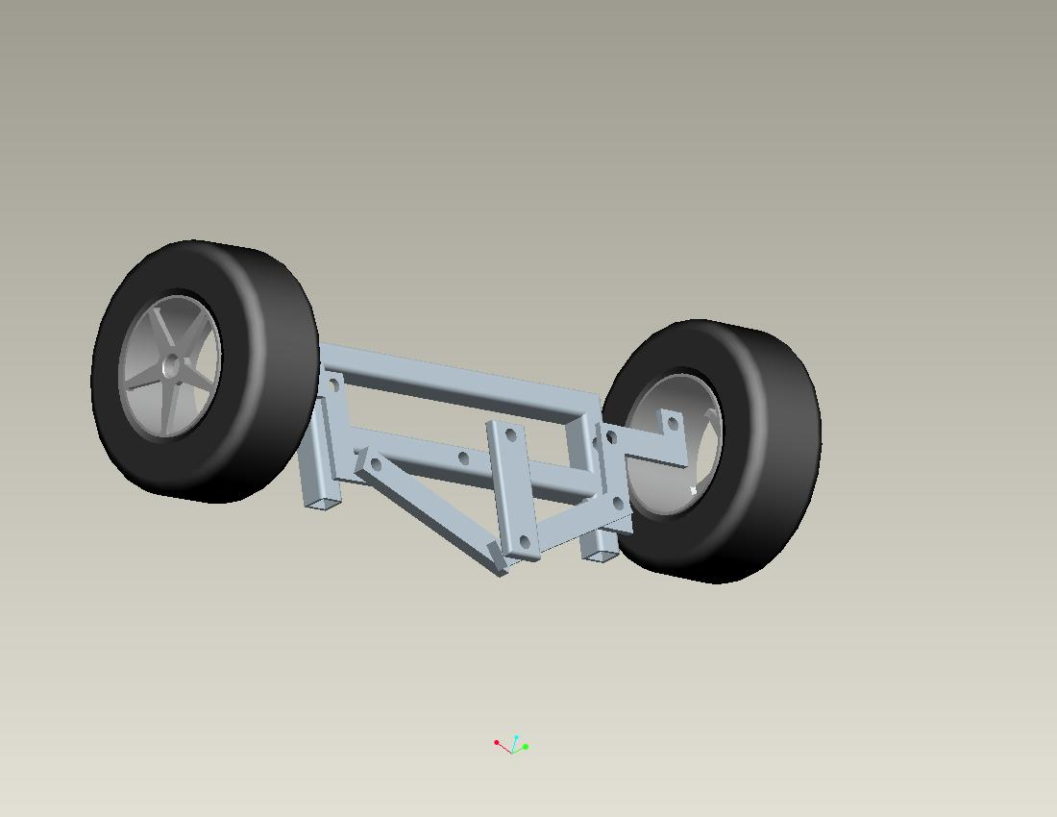

Figure (4) Four-Wheel Ackerman Steering
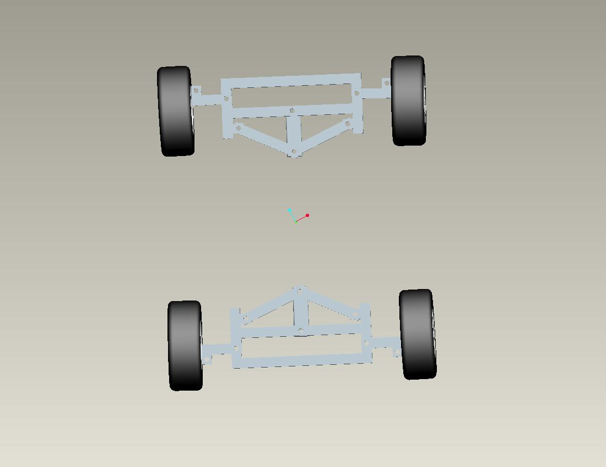

The design shown above was built on the premise that each wheel pair will have its own steering motor. Because of this, there need not be any linkage traveling the length of the vehicle to link the steering (Figure 4). Furthermore, each steering motor will be computer controlled (programming provided by CISCOR), and will transfer motion to the crankshaft centered between each wheel at both the front and rear.

Macpherson Suspension
Our first suspension concept is a Macpherson suspension. This setup consists of a strut connected to a lower control arm, and both the strut and control arm are connected to the frame.

Figure (5) Macpherson Concept
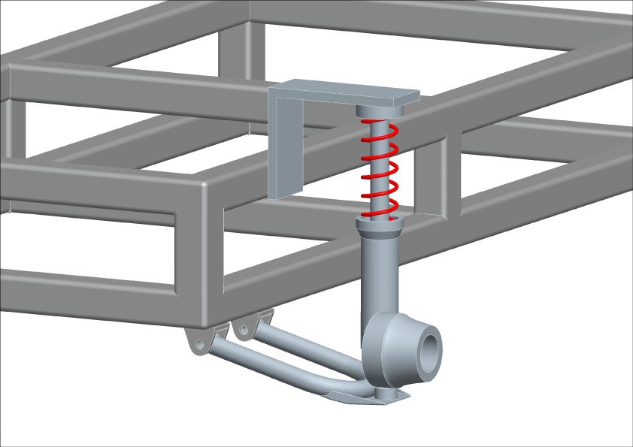

This type of suspension requires minimal side to side space, but because the strut is the upper link of the system, it requires a larger amount of vertical space, thus limiting us in the height of the robot (Figure 5). Other advantages include fewer parts which translate to lower cost, and ease of adjustment for the ground clearance of the vehicle.

Double Wishbone Suspension
A double wishbone suspension is the most common suspension system for front mounted engine, rear wheel drive cars and trucks since WWII. This type of suspension may be used on both the front and rear of the robot. The systems initially had equal length upper and lower control arms, to minimize the amount of camber change in the suspension travel. However modern applications use shorter upper control arms (Figure 6).

Figure (6) Double Wishbone Concept
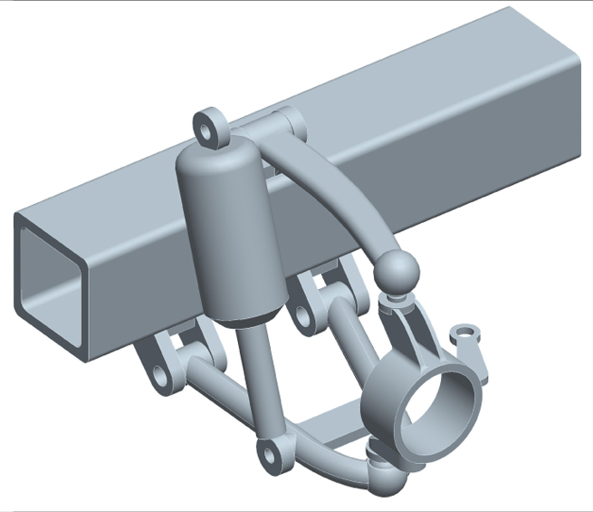

By changing the length of the arms we can control the cornering characteristics of the robot, which will be necessary to keep the robot steady through a high speed turn. More importantly, we must consider the goal of off-road capabilities for the product, and the correctly designed double wishbone suspension can result in more suspension travel than any other set up. This type of suspension is easy to duplicate and very common.

Trailing Arm Suspension
A trailing arm suspension is usually used in the rear of the vehicle. The pivot axes of the control arms are perpendicular to the longitudinal axis of the vehicle. This type of suspension is normally used exclusively on the rear of vehicles, however it can be adapted to work on the front (Figure 7). It is advantageous if we are trying to minimize the track width of the robot because the suspension does not stick out as far as other types. However, it does require a large amount of lateral space to accommodate the trailing arms.

Figure (7) Trailing Arm Concept
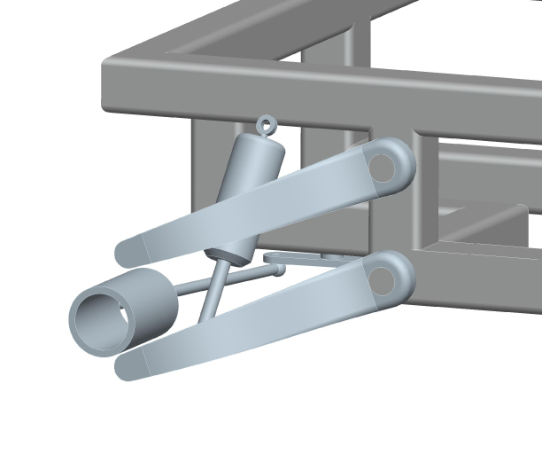
Figure (8) Trailing Arm Concept/Bottom View
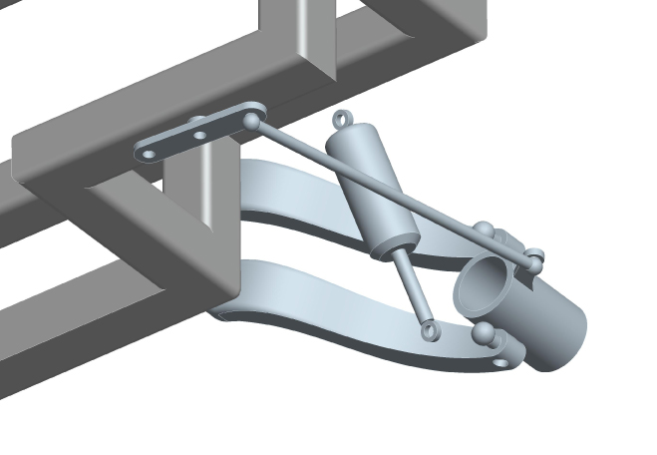

The trailing arm concept also requires modification of the rectangular frame of which the other concepts have been built on. The lower level of the frame has been taken inward at the corners to create space for the mounting of the spring/damper assembly inside the trailing arms, and underneath the frame (Figure 8). This creates additional space to route drive train, and more importantly steering linkage.

Concept Selection

Before choosing a concept it was important that as a group we considered some facts. First off, the steering design is not up for debate, therefore is not considered in the decision matrix. Secondly, frames are paired with suspension design. This leads to the fact that for our decision matrix, we need only consider each of the three suspension design cases generated.
For any product, a decision matrix can be very short, or infinitely long. As a group the important points were discussed, and the attributes from which we based our decisions were those that would directly affect the sought after specifications for the vehicle.
The vertical and lateral spacing of the suspension are the spaces between control arms, and the length of the overall suspension set-up. The increase in width, accounts for the additional width added to the vehicle, from the edge of the frame, to the tire footprint. These are critical components in our final products dimension specifications. For performance, the qualities we rated were speed, off road capability, and ride stability. This directly relates to the primary function of the product as an all terrain vehicle, and how its performance affects the components from which it is constructed. Finally, manufacturing price, parts availability, and fabrication are taken into consideration. For the purposes of concept selection, price refers to raw materials necessary to construct the frame; and should we not be able to find correctly sized off the shelf suspension components, price of material for suspension fabrication. This plays into the availability of parts and number we have to choose from, and is directly related to fabrication difficulty, and time.
Each attribute was given a weight of importance based on the consensus of the group. Additionally, each concept was scored on how closely each individual attribute met and/or could be designed to meet product specifications. When multiplied by the weight factor the result was a final score for each case from which to base our decision from.

Table (1) Decision Matrix

 |  | Option 1 |  | Option 2 |  | Option 3
Attributes | Weights | MacPherson |  | Double Wishbone |  | Trailing arm
 |  | Value (1-10) | Weighted | Value (1-10) | Weighted | Value (1-10) | Weighted
Size
Vertical Spacing | 8 | 7 | 56 | 5 | 40 | 4 | 32
Lateral Spacing | 6 | 2 | 12 | 5 | 30 | 6 | 36
Increase in width | 5 | 5 | 25 | 8 | 40 | 2 | 10
Performance
High Speeds | 4 | 7 | 28 | 8 | 32 | 7 | 28
Off Road | 8 | 3 | 24 | 9 | 72 | 5 | 40
Stability | 9 | 6 | 54 | 8 | 72 | 5 | 45
Manufacturing
Price | 8 | 8 | 64 | 6 | 48 | 7 | 56
Parts Availability | 9 | 7 | 63 | 5 | 45 | 3 | 27
Fabrication | 8 | 7 | 56 | 5 | 40 | 3 | 24
Total |  |  | 382 |  | 419 |  | 298

The result of the decision matrix was a high score for the double wishbone suspension concept, followed closely by the Macpherson. The attributes where the double wishbone shined were the increase in wheelbase, and all around performance. Although the Macpherson suspension proved to score highest in the manufacturing section, its inferiority in the other two sections outweighed its advantages. The trailing arm option, although a solid design, is not a viable option for this product when compared to the better performing technologies.

Conclusion

After creating the design matrix, and considering all the factors, a concept has been chosen. The performance and size of the double wishbone suspension makes it a sound decision. The double wishbone has been used in different types of automotive applications and has proven itself worthy. The matrix only reinforces its dominance. It will provide the best ‘bang for the buck’.
It is the hope of our group, that during the detailed design stage, we will be able to purchase readily manufactured suspension components and apply them to our custom frame. If this is not possible due to the scale of the vehicle, it will not be very difficult to custom fabricate the components to suit our needs. Our final product will have increased wheel travel, as well as off-road capability with this setup. Finally, a double wishbone design will work well with our Ackerman steering concept, and will not interfere with the primary focus of the product.
It was the purpose of this exercise to decide on the concepts with which to enter the detailed design process with. Our group fully believes the best concept has been chosen, and feels it will provide a solid base for the development of CISCOR’s Ackerman steered robot.

Resources

“Car Bibles: The Car Suspension Bible” Car Bibles. 15 October 2008
<http://www.carbibles.com/suspension_bible.html>

Staniforth, Allan. Competition Car Suspension: Design, Construction, Tuning. Newbury
Park: Haynes Publishing, 1999.

Stone, Richard, and Ball, Jeffrey K. Automotive Engineering Fundamentals. Warrendale:
Society of Automotive Engineers, 2004.

